From:

Peak Washington Dysfunction---Or Let Them Eat Loans!
By David Stockman. Posted On Thursday, January 24th, 2019
The Donald took to sticking out his glass jaw again this morning---this time boasting that he's created more jobs than ever before.
The economy is doing great. More people working in U.S.A. today than at any time in our HISTORY. Media barely covers!
That's factually true, of course, but the Donald should please to spar us the CAPS.
Actually, it was the businesses, workers, entrepreneurs and investors of capitalist America who created all those jobs. And notwithstanding the endless abuse they are subjected to from both ends of Pennsylvania Avenue, these indefatigable agents on the free market keep pushing the American economy and job count uphill---no matter who is the temporary sojourner in the Oval Office.
Indeed, insofar as we can tell, every single President since the BLS was invented has claimed more people working "than at any time in our HISTORY". On that score, at least, they were apparently not lying.
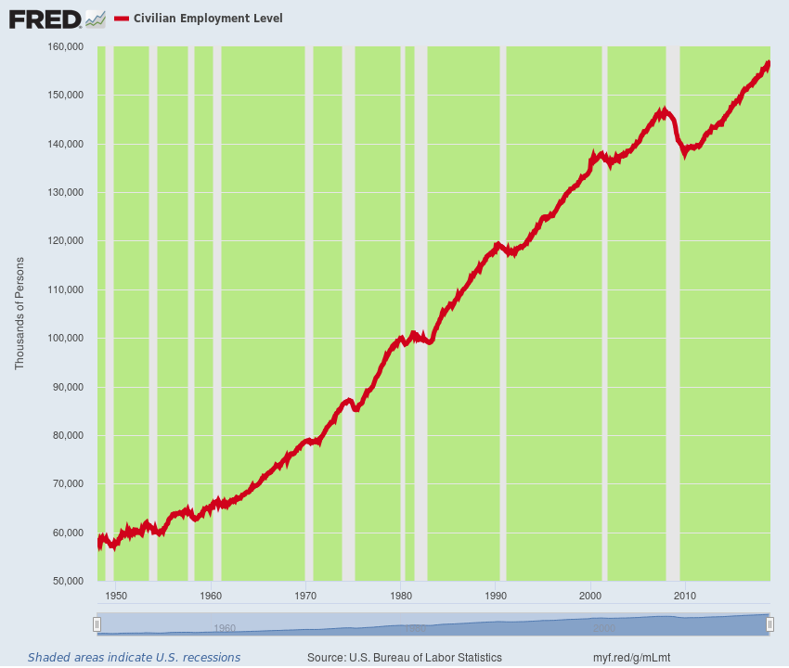
But you don't get to take credit for the sunrise each day----just because you happen to be hanging around the basket at daybreak. The litmus test, therefore, is whether Washington's perennial interference with capitalists growth is being curtailed or intensified under whatever regime happens to be in power at the moment.
Needless to say, the answer to that question is a no-brainer when it comes to the Donald's dog's breakfast of Trade Wars, Border Wars, Fake Money and Fiscal Profligacy. That is, he has gleefully embraced the debt-ridden, speculation-saturated and industrially hollowed-out economy he inherited in the mistaken belief that it is "strong", and these misbegotten policies now threaten to make it substantially worse.
That's the only thing that can possibly happen when you smack a feeble, geriatric 115-month old business expansion, which is barely 4 months from the all-time duration record, with massive, inflationary tariffs and a collision in the bond pits which is simply off the charts of historical experience.
As to the latter point, it should never be forgotten the Trumpite/GOP has now enacted the most counterproductive and irresponsible fiscal policy action in modern history. Or even ever.
After all, the Donald inherited a real bad boy---a built-in $700 billion deficit for the current fiscal year (FY 2019). Relative to GDP, it was already off the charts at this extremely late stage of the business cycle. Once upon a time, in fact, even dyed-in-the-wool saltwater Keynesians insisted fiscal deficits be curtailed or eliminated entirely at the tippy-top of the business cycle.
But the King of Debt was nonplussed, electing to tap Uncle Sam's credit card to fund $300 billion of tax cuts ($285 billion revenue loss plus interest) during the current year alone, and upwards of $2 trillion with interest over the coming decade.
Moreover, no sooner had the abominable Christmas Eve Tax Cut been enacted than the Donald doubled-down, keeping the government's lights on by signing the Horribus appropriations bill last February. So doing, he traded $63 billion of higher domestic spending and more than $100 billion of unfinanced disaster relief for $80 billion of added defense money.
In all, the Trumpite/GOP has pushed the coming year's borrowing requirement toward $1.2 trillion. This means, in turn, that the bond pits will be flooded with $1.8 trillion of "homeless" treasury paper after accounting for $600 billion of existing debt the Fed will be dumping back into the market under its QT (quantitative tightening) program.
Here's the thing. No one has ever tried---or even contemplated---financing government paper amounting to $1.8 trillion or 8.8% of GDP at the tippy-top of a business cycle---and one which will actually enter record old age (123 months) before FY 2019 is over.
Indeed, the very idea of it is pure madness. This thundering collision in the bond pits alone will shatter the nation's entire Bubble Finance economy before it is done.
By way of historical comparison, the Federal deficit was $160 billion or 1.1% of GDP at the top of the last cycle (FY 2007) and the Fed was still buying the public debt, not dumping it.
In fact, it bought $30 billion of Treasury paper that year, meaning the net burden in the bond pits was $130 billion or just 0.9% of GDP.
So what looms just ahead is a flood of government paper into the bond pits which will be 10X bigger (relative to GDP) than was the case at the last cycle peak on the eve of the financial crisis.
Moreover, if you go back to the cyclical peak in the FY 2000, the Federal budget had posted a $235 billion surplus and the Fed's balance sheet had purchased another $25 billion.
So back then at the cyclical peak, Washington actually removed $260 billion of supply from the bond pits----a sum that amounted to 2.6% of GDP and obviously eased the burden on interest rates rather than massively pressuring them as at present.
In short, when you are at the top of the second longest business cycle in history, it is far past the time to be bragging about the current economy and the allegedly good data flashing in the rearview mirror; and completely bonkers to be unleashing a tsunami of government debt into bond markets saturated with drastically underpriced and unsustainable public and private debt
That's especially true when the external headwinds facing the current aging cycle are absolutely ferocious compared to what prevailed when the record 119 month run of the 1990s finally rolled over into recession in March 2001.
Back then, there were virtually no macroeconomic headwinds visible. The Federal budget was running the aforementioned surplus; the Fed had finished its tightening cycle at a 6.5% funds rate nine months earlier and was under no pressure to further tighten; Europe was busting out of the single-currency starting gates; and the Red Ponzi was just finding its export sea legs and had only $2 trillion of debt.
Today's circumstances are the opposite----with massive headwinds accumulating like never before. The European economies are again rolling over, with its German engine of growth likely to post two consecutive quarters of negative GDP growth for the year just ended.
That's because global trade is slowing sharply and Chinese demand for capital goods and luxury consumer goods has plummeted---taking German manufacturing orders with it.
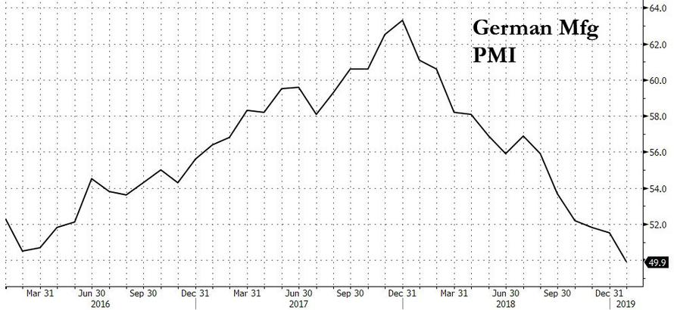
An unlike in 2000, when China had less than $2 trillion of total debt and a leverage ratio not much above 100% of GDP, today the Red Ponzi sits precariously atop $40 trillion of debt and an economy drowning in wasteful malinvestment, hideously inflated real estate markets and inexorably slowing GDP growth.
With the cycle at 115 months of age, therefore, any of those headwinds could trigger a downturn. But in combination they make the odds of a US recession during the next 12-24 months overwhelming.
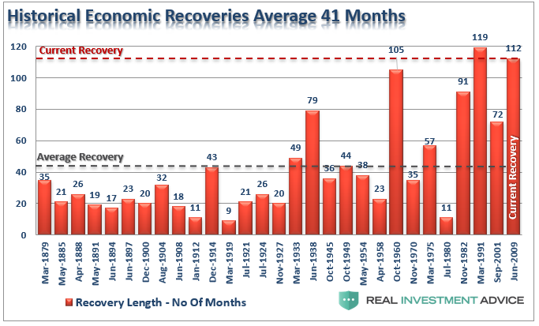
Needless to say, there is nothing strategic or even tactical about the Donald's foolish embrace of an aging stock market bubble and wizened economic cycle. It was just a glandular lurch---the impulsive action of an incorrigible megalomaniac grasping for anything which can be portrayed as a personal "win".
In fact, the Trump Bubble---which the Donald has embraced with all fours---will prove to be the most lunatic stock market mania of modern times. As its implosion now gathers force, even the casino revilers will soon be shaking their heads in a grand consternated chorus of "what were we thinking?"
What kept the insane Trump Bubble going as long as it did, of course, was nine-years of embedded mental muscle memory in the casino. The latter held that buying the dip always---but always---results in a profitable gain. And now--even after the thundering pre-Christmas warning---they are back seemingly every afternoon for one more rip on the momo train.
That's especially so for Wall Street insider speculating with the various forms of carry trade leverage available in the options market or from the bespoke trading desks of Goldman and the other big gambling houses.
They naively believe that both the Fed and the powers that be in Washington can be intimidated into market propping rescue missions any time they stage a hissy fit like the 3% plunge in the averages in Christmas eve.
At the end of the day, however, that [is] just evidence of the immense damage to honest price discovery in the money and capital markets that has been wrought by the Fed's decades long spree of money pumping and stock market coddling and price-keeping actions.
That is, if you survived the plunge between the Lehman bankruptcy in September 2008 and the March 2009 bottom, there were literally 50 buyable dips during the years of fabulous gains which followed. Getting rich had never been so easy.
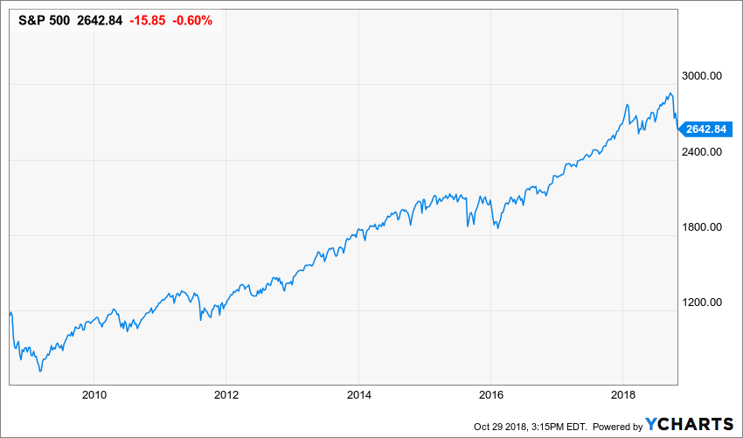
But here's the thing. The one-way market depicted in the graph above was not on the level. It was the malefic handiwork of the Fed and its global convoy of fellow-traveling Keynesian central bankers. Its extended run in financial fantasyland finally extinguished every remnant of fear in the casino---until some time in early October when the last mullets standing presumably took the bait.
The Chart-Monkeys Will Go Screeching Out Of The Casino
Now comes the reckoning, and at the mechanical level its not all that complicated. When there are no dip-buyers left---why then the trading charts get eviscerated and the chart-monkeys go screeching out of the casino.
To wit, back on October 3rd when the S&P 500 re-tested its September 2o Trump Bubble peak at nearly 2930, the index was safely above its alleged multiple layers of support; it had printed 2% above its 50-DMA, 6% above its 200-DMA and 11% above its 350-DMA (50 week).
Yet during the next 60 trading days thru Christmas Eve, the index plunged through its vaunted supports like a hot knife through butter. Every one of them was blown away including the 50-week average, which is considered the absolute Maginot Line by the chart monkeys.
And that was only a forewarning of the potential for a sickening freefall which lies ahead. After all, when you finally reach a bubble's asymptote there is no one left up there in the nosebleed section of the casino except other sellers.
At the same time, there is also no one left in Washington to rescue the casino this time around the barn.
In fact, we have now reached the state of Peak Dysfunction. The bipartisan clowns now in power on both ends of Pennsylvania Avenue can't even agree on the time and place for the president's State of the Union Address----even though it amounts to little more than 75 minutes of political hot air, hypocritical rhetoric and a laundry list of unaffordable promises.
Indeed, today's exchange between the Donald and Nancy tell you all you need to know. There is not a snowball's chance in the hot place that Washington can agree on anything---including an extension of the debt ceiling which expires in early March.
Said the Donald:
I have been assured by national security officials there are no security concerns regarding the State of the Union address” and “therefore, I will be honoring your invitation.”
“It would be so very sad for our country if the State of the Union were not delivered on time, on schedule, and very importantly, on location!”
Speaker Pelosi, however, was having none of the Donald's threat to invade the U. S. House of Representatives, whether invited or not:
The House of Representatives will not consider a concurrent resolution authorizing the president's State of the Union address in the House chamber until government has opened,” she wrote.
And that gets us to (purported) billionaire Wilbur Ross' comments on CNBC Squawk Box this AM with respect to all the whining about the hardship of a 32-day shutdown on the 800,000 Federal bureaucrats who have now gone without two paychecks.
Yet for once the Donald's doddering old Commerce Department Secretary was spot on. To wit,
- the average Federal employee makes $80,000 per year;
- ought to have plenty of cash in the bank or unused credit;
- is eligible for unemployment insurance anyway; and
- will absolutely be paid back after the shutdown is over, as has been the case ever since these events begin to happen back in the 1970s when your editor lived through 8 of them as a member of Congress and OMB director.
Said Wilbur:
"I know they are [going to homeless shelters] and I don't really quite understand why because as I mentioned before, the obligations that they would undertake – say borrowing from a bank or credit union – are in effect federally guaranteed," said Ross. "So the 30 days of pay that people will be out – there's no real reason why they shouldn't be able to get a loan against it and we've seen a number of ads from the financial institutions doing that."
"When you think about it, these are basically government-guaranteed loans because the government has committed, these folks will get back pay once this whole thing gets settled down," Ross said. "So there really is not a good excuse why there should be a liquidity crisis. Now true, the people might have to pay a little bit of interest but the idea that it's paycheck or zero is not a really valid idea."

Folks, that is the greatest indictment imaginable of the Donald's "strongest economy ever". All of the above should be true, but the sad fact is that even the aristocracy of American labor [Government Employees] now lives hand-to-mouth on biweekly pay cycles at Wal-Marts and Amazon.
And that's the very opposite of "strong"; it's actually evidence of a fragile economy that will go down for the count next time the stock market crashes hard and the C-suites trigger another binge of layoffs, inventory liquidations and restructuring campaigns designed to appease the trading gods.
This time there will be no Washington fire brigade to arrest the carnage and double-down on money printing and debt.
West Virginia Sen. Joe Manchin apparently knows whereof he speaks. Even though the average Federal employee in West Virginia hauls down a salary (before benefits) of $78,000 per year, they are apparently only a few weeks away from the soup lines:
"I've been all over West Virginia, people are hurting," he said. "They've got no cash flow. Making decisions, do I put gas in the car or do I feed the kids? This is real."
Surely he exaggerates. But then again the chart below suggests he might better be taken at his word anyway.

